**In class Programming Assignment – 1**

**Github Link:** https://github.com/RishikaMadireddy/Neural-Networks-ICP1

**Problem 1:** Input the string “Python” as a list of characters from console, delete at least 2 characters, reverse the resultant string and print it.

**Input:** python

**Output:** ntyp

**Solution:**

1. String is taken from the user and then it is stored in ‘input_string” variable.

2. The last two characters were deleted using the string-slicing operator and stored in the "resultant_string" variable.

3. Finally, the string is printed in reverse order.

**Arithemetic operations:**

1. Any two integers are considered from the user and perfomed 4 arithmetic operations on those numbers.
2. The ouput is now printed as shown below

**Code:**

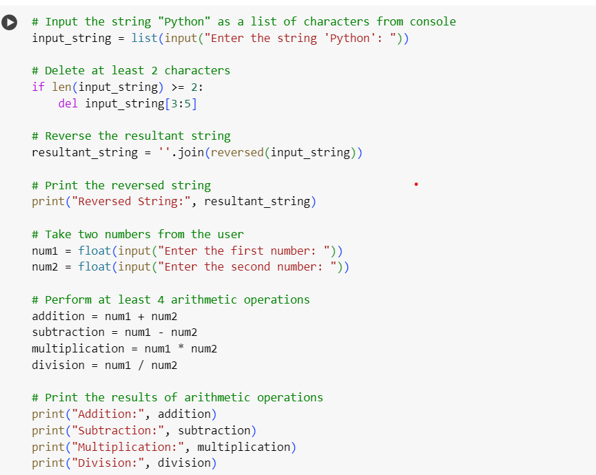

**Output:**

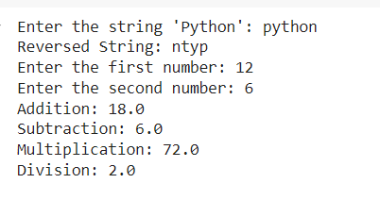

**Problem 2:** Write a program that accepts a sentence and replace each occurrence of ‘python’ with ‘pythons’.

**Input:** String

**Output:** String

**Solution:**

1. Enter a sentence of the user choice

2. Using the sentence.replace(sub_string1, sub_string2) method, the word ‘python’ is replaced with ‘pythons’. This method takes an input string and replaces every instance of sub_string1 with sub_string2.

3. The resultant string is printed on the console.

**Code:**

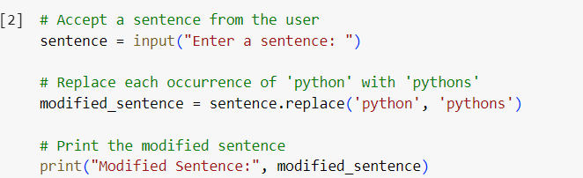

**Output:**

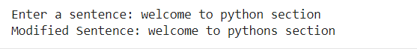

**Problem 3:** Use the if statement conditions to write a program to print the letter grade based on an input classscore. Use the grading scheme we are using in this class.

**Input:** Integer

**Output:** String

**Solution:**

1. Considering a program taking an integer as input from the user and stores it in the "class_score" variable.

2. Using if and elif conditions, the value is categorised for the criteria for a grade.

3. When the variable matches the condition, the corresponding print function is executed, and the grade is displayed on the console.

**Code:**

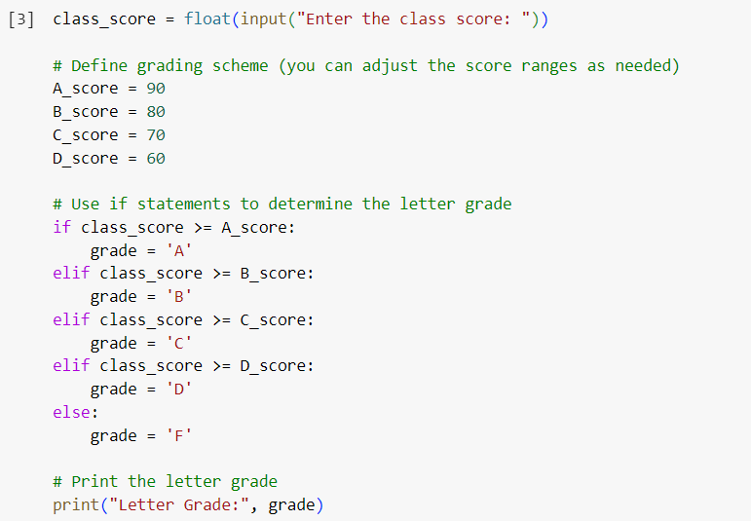

**Output:**

